Websitecasa Webdesign
US (832) 541-2161 – UK 07708467383 – mywebsitecasa@gmail.com

Submitting your content correctly is the best way to speed up the build of your site. We use the content that you submit to build your site. We are not responsible for proofreading or creating content (unless you have purchased one of those support services).

Each page in your word document should correspond with the page on your website.

Please use the following pages as a best practice guide to submitting your content.

PAGE ONE: Explain how you would like your menu set-up

Menu items:

Home
About
Website Design
Web Development
Hosting and Domains
Social Media and Marketing
Digital Distribution
Support
Services
Get started
Portfolio
Contact

Use BOLD to indicate main menu items
Use lowercase and a tab to indicate sub-menu items

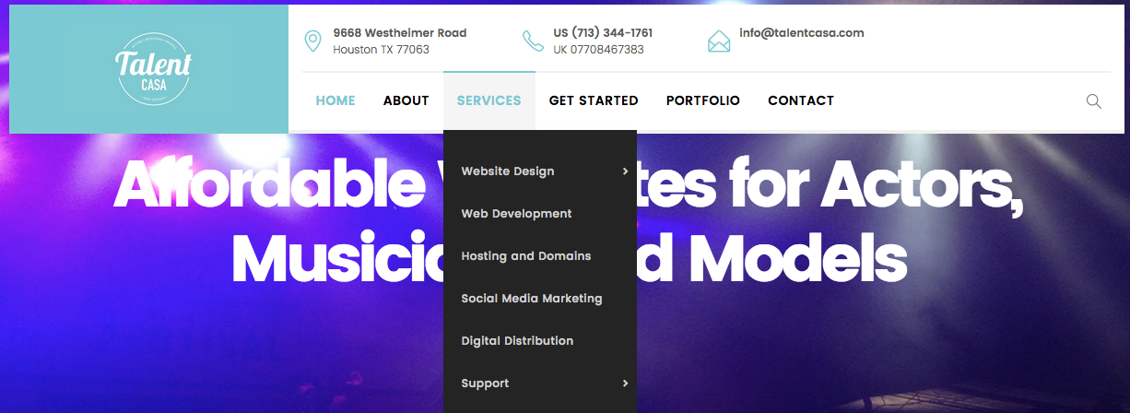

NEXT PAGE: Page name and content:

Home Page:

Web Design Services
We offer a full range of web design services. We specialize in affordable website design services for actors, models and musicians.

Please highlight any special instructions to ensure that they stand out i.e.… “I would like to this page to have 3 images on it.”

The standard Lorem Ipsum passage, used since the 1500s
"Lorem ipsum dolor sit amet, consectetur adipiscing elit, sed do eiusmod tempor incididunt ut labore et dolore magna aliqua. Ut enim ad minim veniam, quis nostrud exercitation ullamco laboris nisi ut aliquip ex ea commodo consequat. Duis aute irure dolor in reprehenderit in voluptate velit esse cillum dolore eu fugiat nulla pariatur. Excepteur sint occaecat cupidatat non proident, sunt in culpa qui officia deserunt mollit anim id est laborum."

Section 1.10.32 of "de Finibus Bonorum et Malorum", written by Cicero in 45 BC
"Sed ut perspiciatis unde omnis iste natus error sit voluptatem accusantium doloremque laudantium, totam rem aperiam, eaque ipsa quae ab illo inventore veritatis et quasi architecto beatae vitae dicta sunt explicabo. Nemo enim ipsam voluptatem quia voluptas sit aspernatur aut odit aut fugit, sed quia consequuntur magni dolores eos qui ratione voluptatem sequi nesciunt. Neque porro quisquam est, qui dolorem ipsum quia dolor sit amet, consectetur, adipisci velit, sed quia non numquam eius modi tempora incidunt ut labore et dolore magnam aliquam quaerat voluptatem. Ut enim ad minima veniam, quis nostrum exercitationem ullam corporis suscipit laboriosam, nisi ut aliquid ex ea commodi consequatur? Quis autem vel eum iure reprehenderit qui in ea voluptate velit esse quam nihil molestiae consequatur, vel illum qui dolorem eum fugiat quo voluptas nulla pariatur?"

1914 translation by H. Rackham
"But I must explain to you how all this mistaken idea of denouncing pleasure and praising pain was born and I will give you a complete account of the system, and expound the actual teachings of the great explorer of the truth, the master-builder of human happiness. No one rejects, dislikes, or avoids pleasure itself, because it is pleasure, but because those who do not know how to

NEXT PAGE: Page name and content:

About:

Follow the same process until you have provided the content for each of the pages you want on your website.
TALENTCASA is web design company that offers support to Musicians, Models, Singers & Labels looking to build and promote a professional website at an affordable price.
As part of the Quiz Media Group we have been providing services since 1992. We have offices in New York, LA, Atlanta, Houston, Miami and London. We work with new and established companies to make sure that they achieve their design needs.
We build and promote custom websites that will get you noticed! Our design team is fast and friendly. We can take your idea and make it a reality at a very reasonable price.
We also offer digital music distribution.

Philosophy
Our company philosophy is to create the kind of website that will excite you: easy to find, stylish and appealing, quick loading, mobile responsive and easy to buy from.

Section 1.10.32 of "de Finibus Bonorum et Malorum", written by Cicero in 45 BC
"Sed ut perspiciatis unde omnis iste natus error sit voluptatem accusantium doloremque laudantium, totam rem aperiam, eaque ipsa quae ab illo inventore veritatis et quasi architecto beatae vitae dicta sunt explicabo. Nemo enim ipsam voluptatem quia voluptas sit aspernatur aut odit aut fugit, sed quia consequuntur magni dolores eos qui ratione voluptatem sequi nesciunt. Neque porro quisquam est, qui dolorem ipsum quia dolor sit amet, consectetur, adipisci velit, sed quia non numquam eius modi tempora incidunt ut labore et dolore magnam aliquam quaerat voluptatem. Ut enim ad minima veniam, quis nostrum exercitationem ullam corporis suscipit laboriosam, nisi ut aliquid ex ea commodi consequatur? Quis autem vel eum iure reprehenderit qui in ea voluptate velit esse quam nihil molestiae consequatur, vel illum qui dolorem eum fugiat quo voluptas nulla pariatur?

Section 1.10.32 of "de Finibus Bonorum et Malorum", written by Cicero in 45 BC
"Sed ut perspiciatis unde omnis iste natus error sit voluptatem accusantium doloremque laudantium, totam rem aperiam, eaque ipsa quae ab illo inventore veritatis et quasi architecto beatae vitae dicta sunt explicabo. Nemo enim ipsam voluptatem quia voluptas sit aspernatu
NEXT PAGE: Page name and content:

Footer:

You will also need to provide any special instructions that you might have for the footer
Our sites are mobile friendly and come with all the features you expect from a professional website. We work exclusively with WordPress themes and all hosting is provided by Godaddy.com.
9668 Westheimer Road, TX
Tel: US (713) 344-1761 / UK 07708467383

Quick Links
- ABOUT US
- Get Started
- Digital Distribution
- Hosting and Domains
- CONTACT US
- Support

LAST PAGE: Special instructions or guidance:

Use this page to provide any special instructions that you have.

Example:

“I would like the text to be black and all heading to be bold and in Blue text”

